Linux commands
- Echo
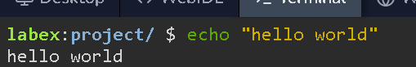
- Whoami
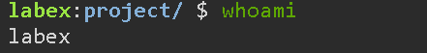
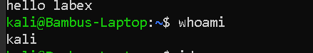
3.id
Gives the uid , group id ,
you used whoami to display your username. In step 3, you used id to display user and group information.
4. Id root
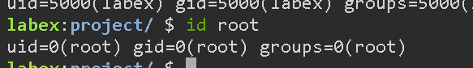
5. Display user
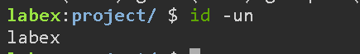

6. Ls:
list file
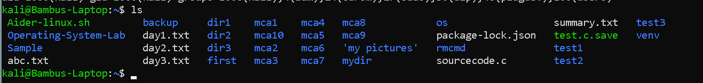
7.pwd
Directory path

8. Mkdir
Make a directory
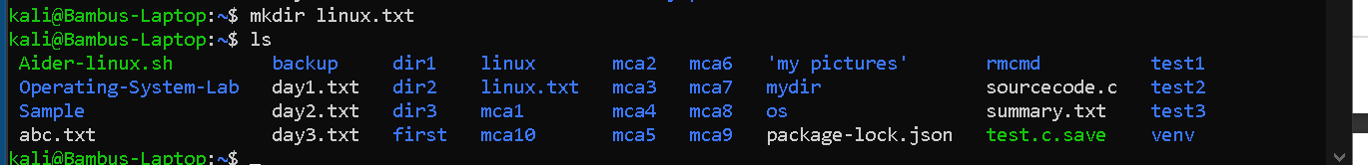
9. Rm
Remove
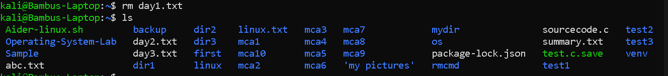
10 .touch
Make a file or txt
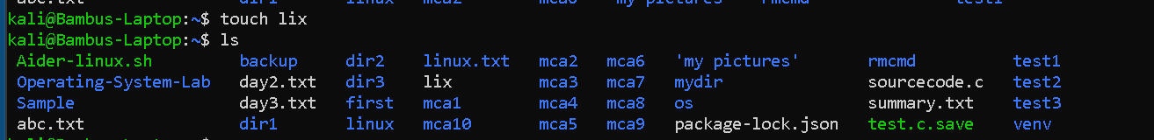

Touch many in single line
11. Expr
Add or perform calculation

12. Variable
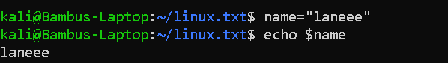
Heere $ is used to extract value from name

13.history
Gives history of it

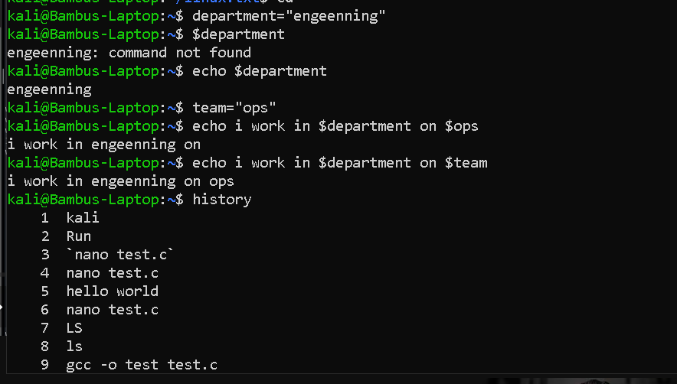
14.Cat
Display the content into it
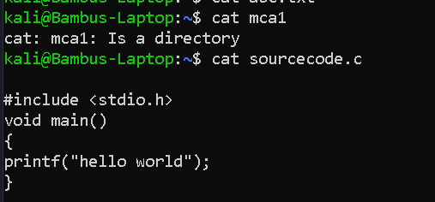

15. Head and tail
Display what how many lines is needed
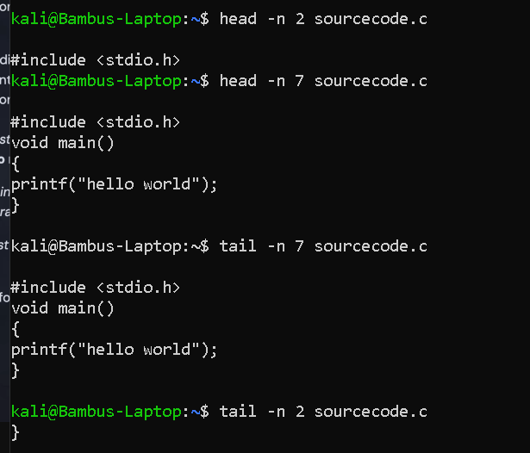
syntax
Head -n 2 source.code

16. Mv
Move or rename file or directory
17 .rm ( remove)

To remove directory use
Rm -r first
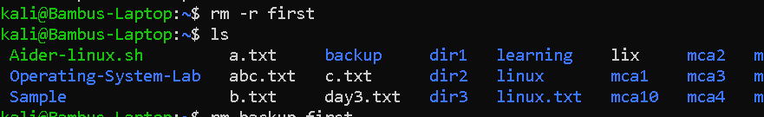

Rm lix
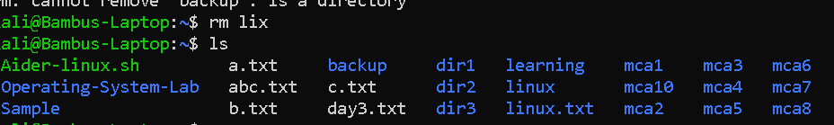
18. Grep
Mean ctrol f it search for a value in it or not
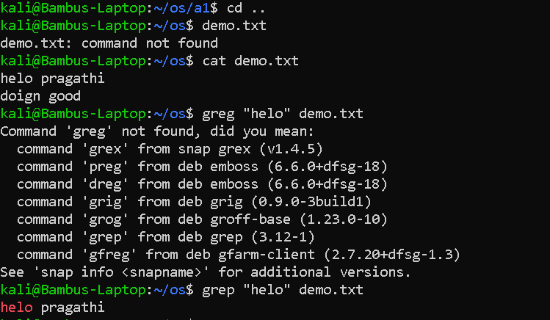
19. Sudo
Base for everything every line needs this when doelaoding something

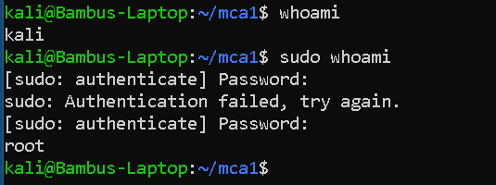

PERMISSION

IN UNIX IS ALLOWING user to read , write or execute
*********
In this first * can be either D or - means directory or a text file
Next 3 *** can be r w x read write execute(owner)
R - x can read and execute only
Next 3 *** can be r w x read write execute(group)
Next 3 *** can be r w x read write execute(everyone)
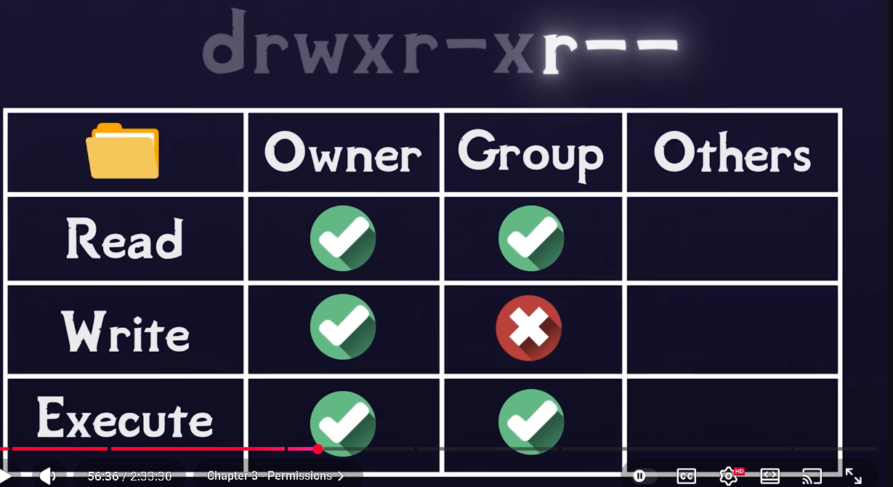
20. Chmod
Change mod
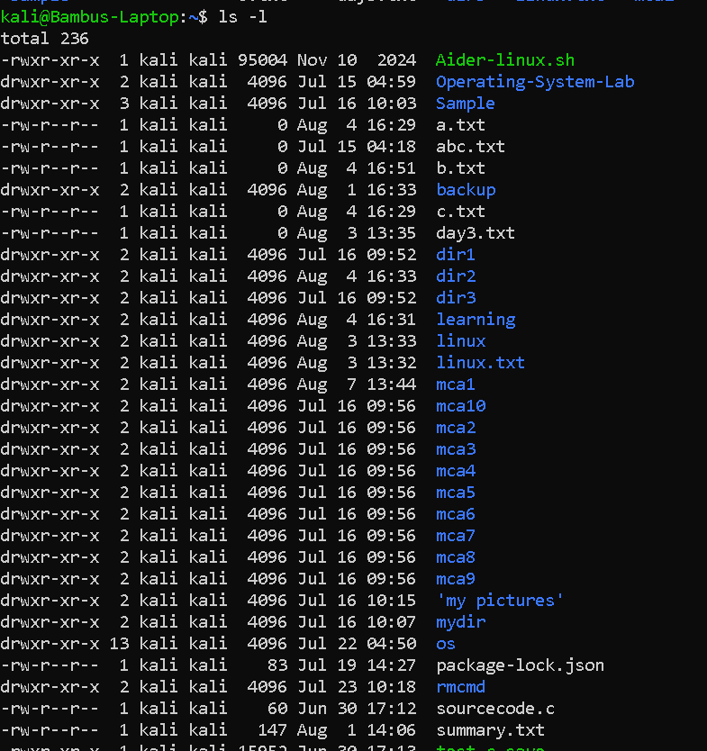
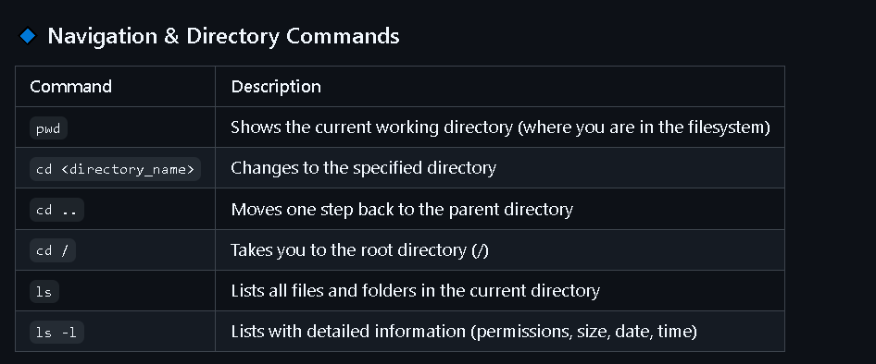
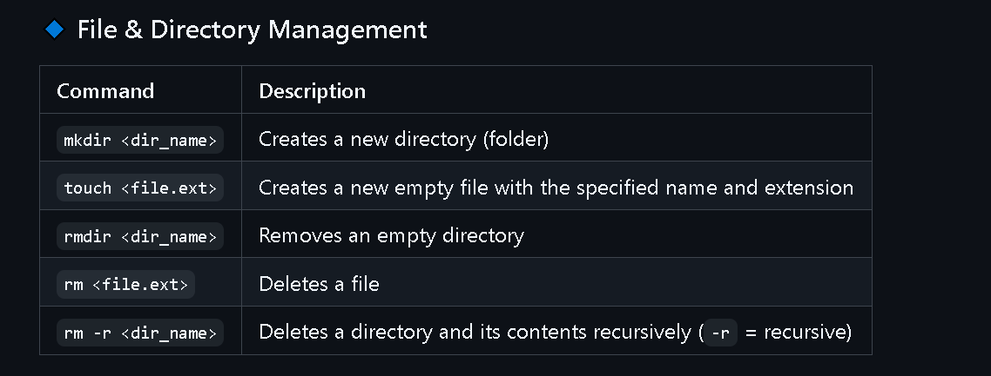
21. Equal to
-eq
-eq → equal

22. And
&& → AND

23. Or
|| → OR

24. Elif
elif → else if
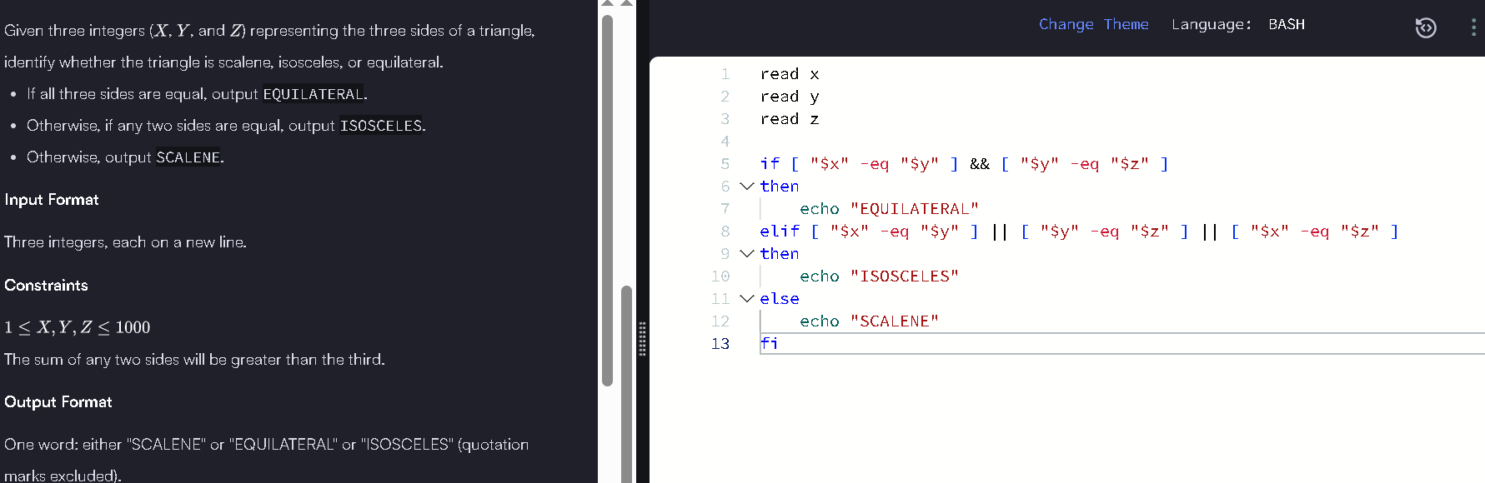

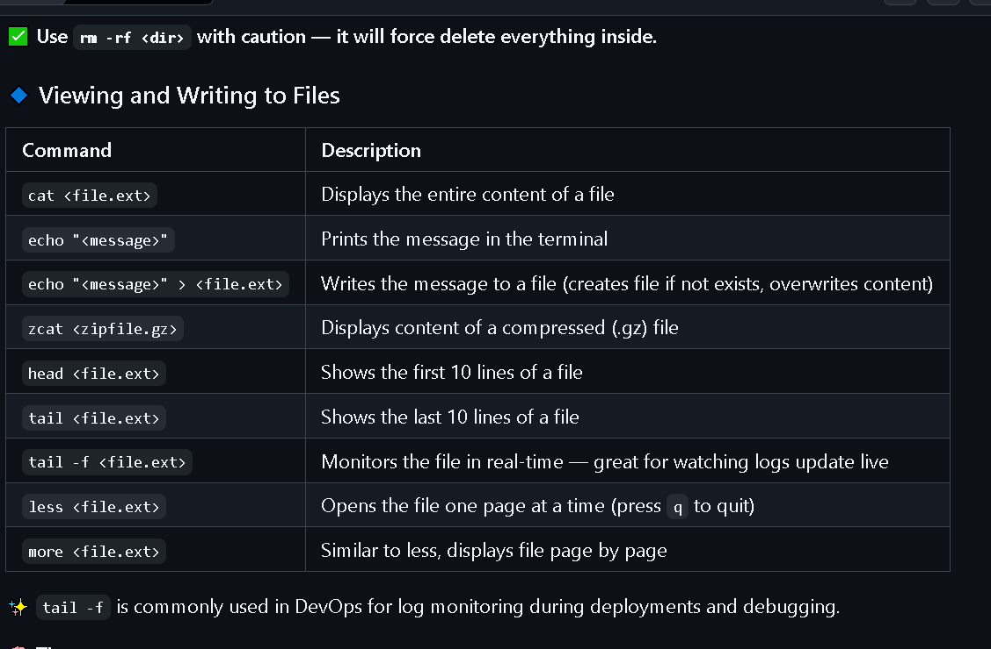

25 -e escape sequences
26 -c
27 \b
28 \c
29 \n, \t
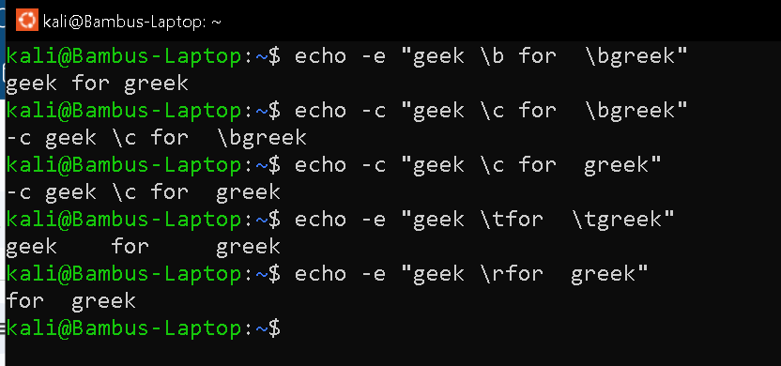
30 \v
31 \a sound alert

32 echo *
Same as ls
But all will be same white colour
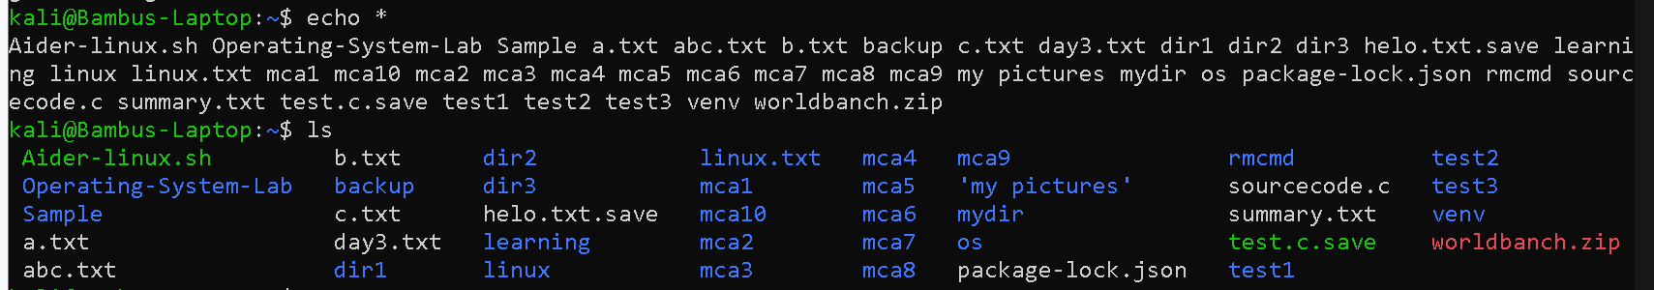
33 >( redirection symbol )
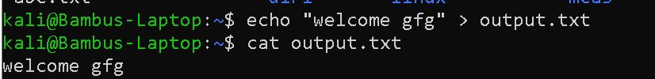
34 display some thing in file
Cat
Above code
35 cp( copy )
Cp used to create backup , copy content or
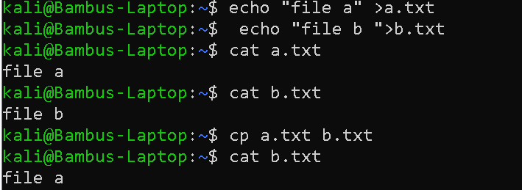
Copying using cp
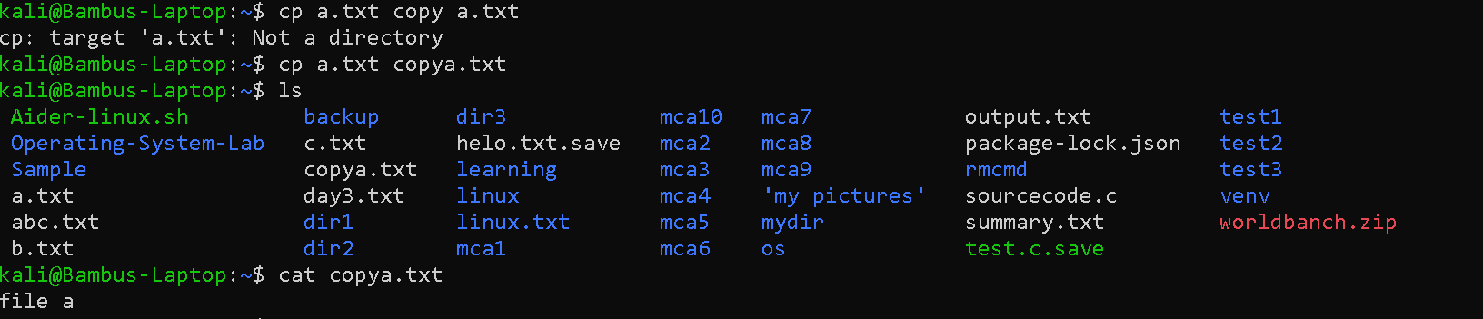

Copying multiple file in directory
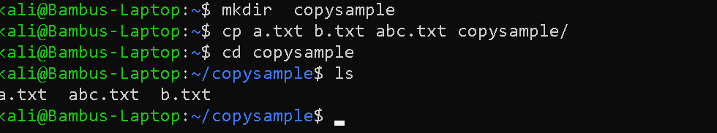

Copying a directory

Locate
Locate faster than find
It is to find a thing faster
Locates it finds faster in databases first
36 . cut command
Extract content from each line
To create a file use cat
Make 2 file
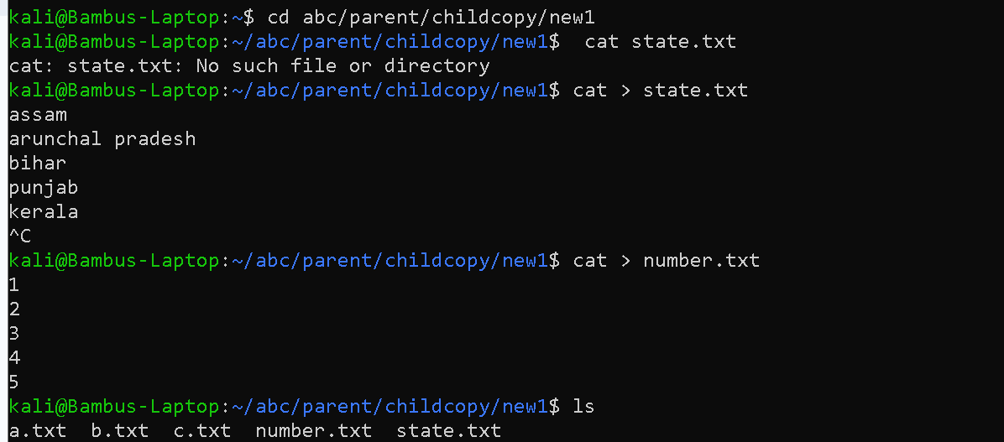
Extract content 3 ways
-b
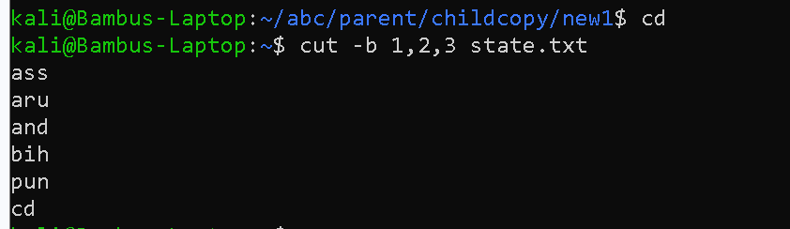
1, 2,3 each line first 3 character
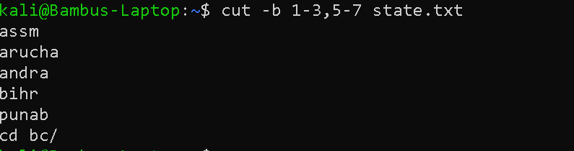
If u specify the range u need
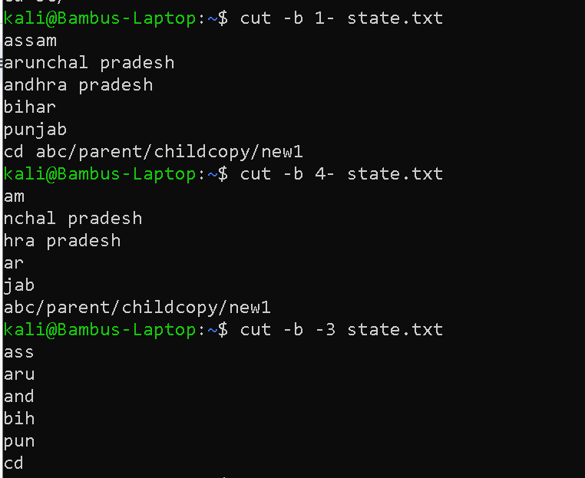
1- full wil be printed frm1
3- from 3 to last
-3 till 3 will be extracted

-c
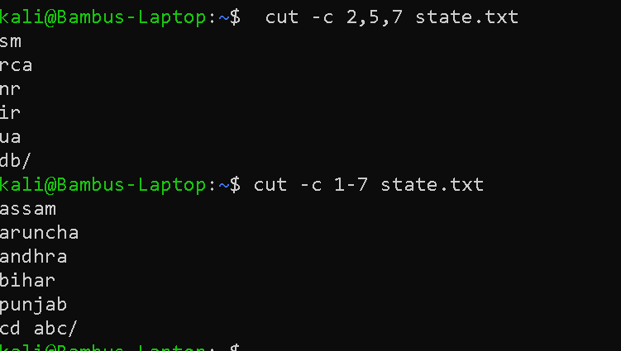
-f field
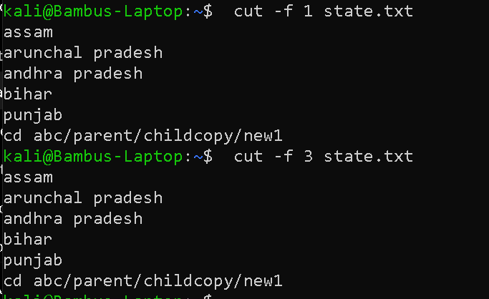
Merge 2 or more file together

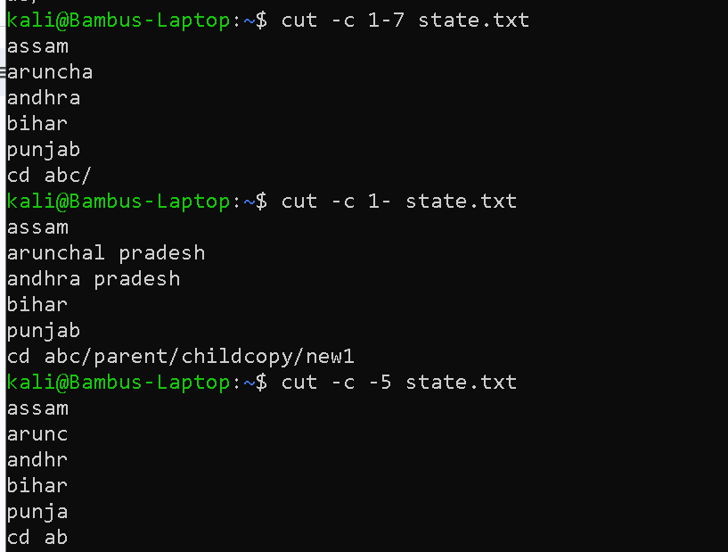
Merge 2 or more file together
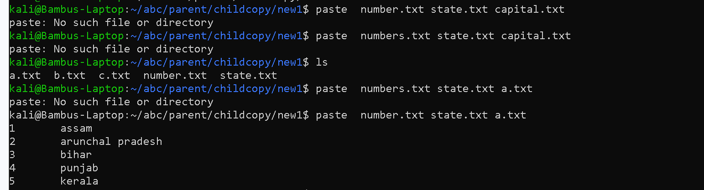
Horizontal
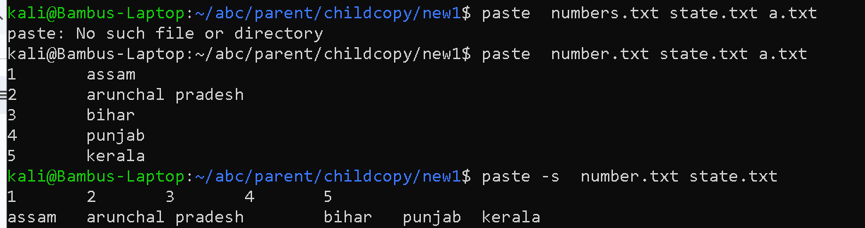

Make it a good formatting
